 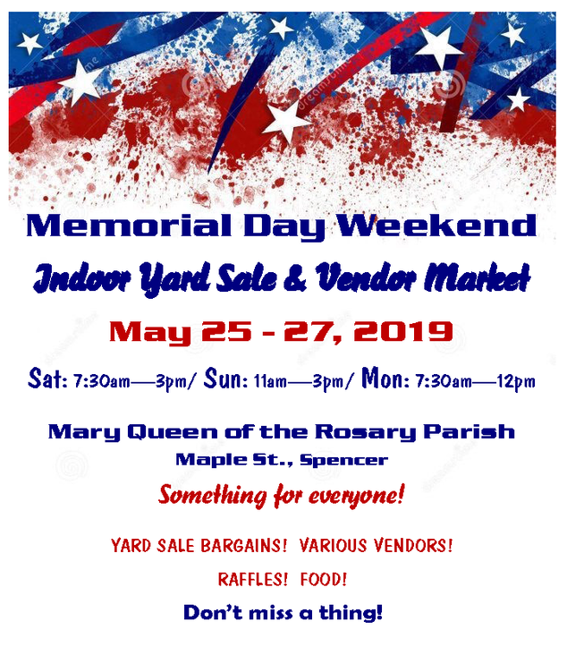

**will be in Plankinton on**

**Tuesday, November 5th, 2019**

**Master Chief Byers will be speaking to the residents at APA from 9:00 – 10:00**

**Please join us at the**

**Plankinton School Gymnasium from 1:00 – 2:00**

**Commerce Street Grille for a fireside chat at 7:00 P.M**

**This is a once in a lifetime opportunity that we hope everyone will be able to see.**

**SOCM Edward Byers was born in Toledo, Ohio in 1979. He grew up in Grand Rapids, Ohio. In 1997, he graduated from Otsego High School where he played varsity soccer. Byers joined the Navy in September 1998 where he attended Corpsman Medical School.**

**Byers spent four years as a Hospital Corpsman. Serving at Great Lakes Naval Hospital and then with 2nd Battalion, 2nd Marines in Camp Lejeune, North Carolina where he earned his Enlisted Surface Warfare Specialist (ESWS) and Fleet Marine Force (FMF) warfare devices.**

**In 2002, Byers attended Basic Underwater Demolition SEAL (BUD/S) training and graduated with Class 242. After graduation, he attended the JFK Special Operations Combat Medic (SOCM) course. Byers has served at SEAL Team 4, Naval Special Warfare Development Group and as a Senior Enlisted Advisor and Action Officer within the Pentagon.**

**Byers has 11 overseas deployments with nine combat tours. His personal decorations include: Bronze Star with Valor (all five awards with valor), Purple Heart (two awards), Defense Meritorious Service Medal, Joint Service Commendation Medal (two awards, one with Valor), Navy Commendation Medal (three awards, one with Valor), Combat Action ribbon (two awards), and Good Conduct Medal (six awards). His most notable unit awards include: Presidential Unit Citation (three awards) and Navy Unit Commendation (two awards).**

**Byers was awarded the Medal of Honor from President Barack Obama during a White House ceremony February 29, 2016 for his actions during a hostage rescue mission as an operator to save an American Doctor while deployed in support of Operation Enduring Freedom in December 2012.**

**Byers is 1 of 13 living service members to be awarded the Medal of Honor for heroism since 9/11 and is the 6th SEAL in Naval Special Warfare's prestigious history to be bestowed this honor. He is the only enlisted Medal of Honor recipient still on active duty in the military.**

**Byers holds a National Paramedics License and a Bachelor Degree in Strategic Studies and defense Analysis at Norwich University.**

**Many thanks to our sponsors – Plankinton Service Club, Hefty Seeds, Pirogues Catering, Plankinton, Mt. Vernon and Corsica-Stickney Schools, APA staff and those who attended our fundraisers.**

***Many thanks to our sponsors – Plankinton Service Club, Hefty Seeds, Pirogues Catering, Plankinton, Mt. Vernon and Corsica-Stickney Schools, APA staff and those who attended our fundraisers.***